**Server Monitor Feedback**

**Drive Information**

* Dashboard section
  + Maybe add a % used
  + Does it indicate if the % used reaches a certain %?

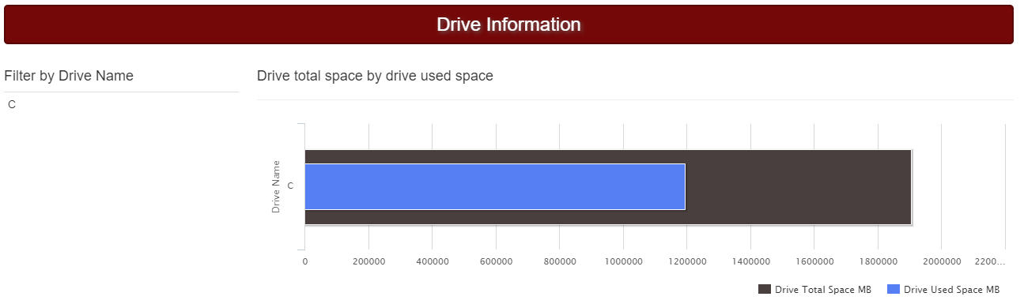

* Drive Information Detail Report
  + Formatting issue with % available space R1.00
  + Calc issue with % Used Space 223.9%
  + Change Name of report IDSC_STATMON_DRIVES

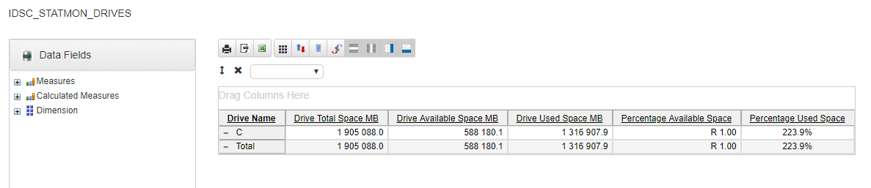

**Database Information**

* Dashboard section
  + Does it indicate if the % used reaches a certain % for both Database used and Log file used?

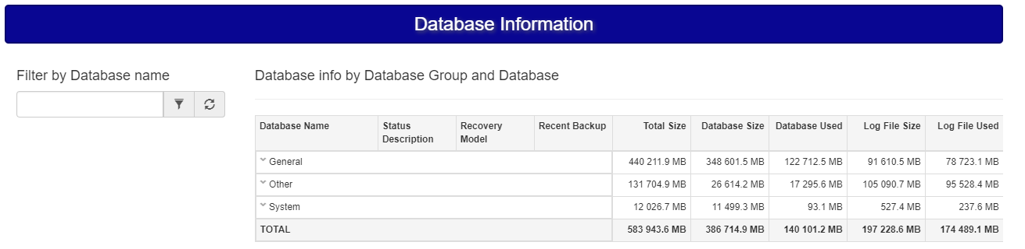

* Database Information Detail Report
  + May be add color code where log file size is greater than database size
  + Change the name of the report IDSC_STATMON_DBINFO

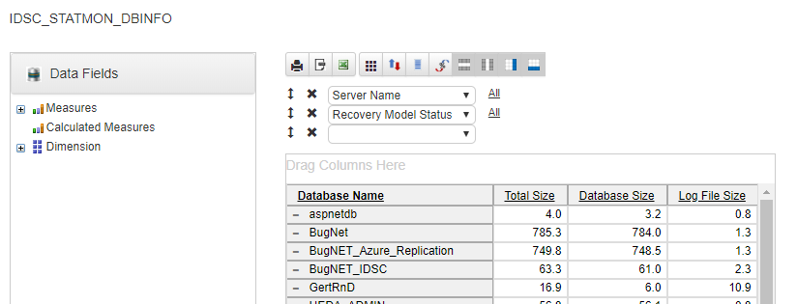

**SQL Job Information**

* Dashboard section
  + Does the last run outcome change if cancelled or failed?
  + Maybe add the duration and avg duration of the job?
  + Maybe indicate where the job ran x% longer than the avg duration of the job

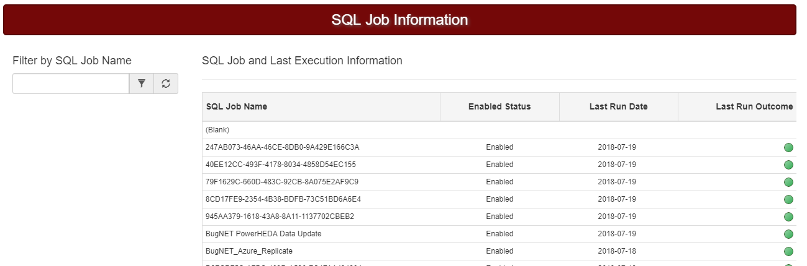

* SQL Jobs Information Detail Report
  + Change the name of the report IDSC_STATMON_SQLJOBS
  + Report layout?
  + What does Last Run Outcome mean (1.0)?
  + Total does not make sense here

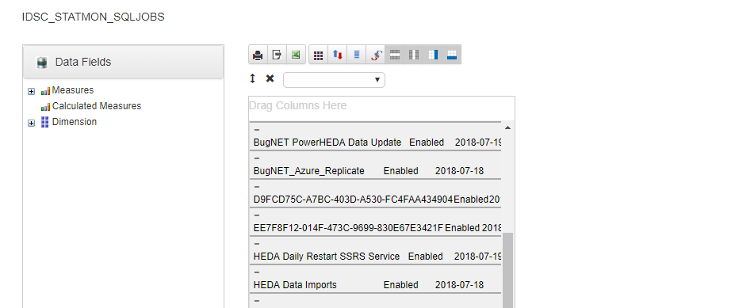

**SQL Health Check Information**

* Dashboard section
  + What does sp_Blitz Findings mean?
  + What does drilldown (Blank) mean? Can this be removed or be changed to Finding or Comment or Note?
  + This is a little over powering, but I can see that it could be useful. What type of information do you want to display here. Tongue in cheek Like the comment under Rundate.
  + Change name of report at the bottom

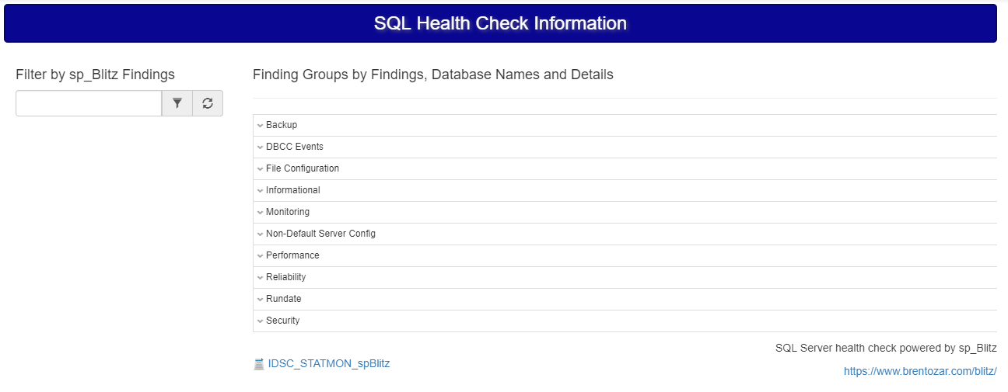

* SQL Jobs Information Detail Report
  + Change the name of the report IDSC_STATMON_spBlitz
  + Like the summarized comments when you drilldown per database
  + What does Check Id and Priority mean?
  + Total does not make sense here

